 

**INSTITUTE FOR**

**ADVANCED COMPUTING**

**AND SOFTWARE**

**DEVELOPMENT AKURDI,**

**PUNE**

Documentation On

**“SCRAP TREADING SYSTEM”**

PG-DAC SEPT 2021

*Submitted By:*

**Group No: 57**

**Kazi Aayaj Shabbir (219086)**

**Shaikh Omair Shaikh Mujahed (219174)**

**Mr. Prashant Karhale Mr. Kashinath Patil**

**Centre Coordinator External Project Guide**

**Mrs. Shilpa Pawale**

**Internal Project Guide**

**Table of Contents**

**1. Introduction** **4**

Problem Statement 4

Aim & Objectives 4

**2. Overall Description** **5**

Proposed Methodology 5

Operating Environment 5

Design and Implementation Constraints 6

**3. Requirements Specification** **7**

External Interface Requirements 7

**4. System Diagram** **8**

Activity Diagram 8

Use Case Diagram 10

ER Diagram 12

**5. Table Structure** **13**

User 13

Scrap Posts 14

Bid Details 14

Feedback 15

Report 15

**6. Conclusion** **16**

Future Scope 16

**7. References** **17**

**List of Figures**

Figure 1 Admin Activity Diagram 8

Figure 2 User Activity Diagram 9

Figure 3 Use Case Diagram for Admin 10

Figure 4 Use Case Diagram for User 11

Figure 5 ER Diagram 12

**1. INTRODUCTION.**

**Introduction:**

This system allows the Users to easily Buy or Sell the Scrap whenever they need with use of this system. This document is meant to delineate the features of Scrap Trading System Portal, so as to serve as a guide to the developers on one hand and software validation document for complete functionality of listing and booking car. In this system, Tourism and Travelling facilities also provide. The prospective client on the other.

**Problem Statement:**

An existing system need physically meet to trade Scrap. The seller has to go in the merchant’s shop where seller has to show Scrap and then buyer will tell the amount and then they can negotiate accordingly. In the existing system seller have to take the scrap to buyer’s shop.

**Aims and Objective:**

The Scrap Treading System is a platform through which we will connect scrap dealer/merchants with people who are possessing scrap in house and want to sell it at reasonable price. At this platform we will take description, type, quantity, photos of scrap from seller and put a post on website where other people [buyers/dealer] can explore it and can put bid for it. Then seller will decide who to sell according to various factors like price, pick up time, ease of transport, etc.

Simple database is maintained.



Easy operations for the operator of the system.



User interfaces are user accommodating and attractive; it takes very less time for the operator to use the system.



The aim is to design a college website which implant update information of the college that should improve expertness of college record management.



**2.OVERALL DESCRIPTION.**

**Proposed Methodology:**

The main page of the website will contain various available post of scrap to be sold. Through this page anybody who is visiting this website will get to see these posts which will be ordered according to latest uploaded post in ascending manner. Various filters will be provided for sorting all post as buyer’s requirement. Filtering conditions like weight, price, type, material, locations etc. This page will also contain approximate current rates of different types of scrap material. The page will also provide Calculator as feature to the users to make their job easy. For bidding user (buyer) must login first. If a user is not registered on the website, then they have to register first using register option. After successful login user can bid for scraps. Buyers or users may filter scraps according to various filtering conditions like weight, price, type, material, locations etc. For uploading post to sell scrap Sellers also have to login first. If a seller is not registered on the website, then they have to register first using register option.

**Operating Environment:**

Server Side:

**Processor:** Intel® Xeon® processor 3500 series

**HDD:** Minimum 500GB Disk Space

**RAM:** Minimum 4 GB

**OS:** Windows 10, Linux 6

**Database:** MySQL

Client Side (minimum requirement):

**Processor:** Intel Dual Core

**HDD:** Minimum 80GB Disk Space

**RAM:** Minimum 2GB

**OS:** Windows 7, Linux

**Design and Implementation Constraints:**

* The application will use JavaScript, ReactJS and CSS as main web technologies.
* HTTP and FTP protocols are used as communication protocols. FTP is used to upload the web application in live domain and the client can access it via HTTP protocol.
* SMTP protocol is used for Email communication.
* Several types of validations make this web application a secured one and SQL Injections can also be prevented.
* Since Scrap Treading System is a web-based application, internet connection must be established.
* The Scrap Treading System will be used on PCs and will function via internet or intranet in any web browser.

1. **Requirements Specification.**

**External Interface Requirements:**

User Interfaces:

* All the users will see the same page when they enter in this website. This page asks the users a username and a password.
* After being authenticated by correct username and password, user will be redirect to their corresponding profile where they can do various activities.
* The user interface will be simple and consistence, using terminology commonly understood by intended users of the system. The system will have simple interface, consistence with standard interface, to eliminate need for user training of infrequent users.

Hardware Interfaces:

* No extra hardware interfaces are needed.
* The system will use the standard hardware and data communication resources.

This includes, but not limited to, general network connection at the server/hosting site, network server and network management tools.

Application Interfaces:

**Web Browser:**

The system is a web-based application; clients need a modern web browser such as Mozilla

Firebox, Internet Explorer, Opera, and Chrome. The computer must have an Internet

connection in order to be able to access the system.

Communications Interfaces:

* This system uses communication resources which includes but not limited to, HTTP protocol for communication with the web browser and web server and TCP/IP network protocol with HTTP protocol.
* This application will communicate with the database that holds all the booking information. Users can contact with server side through HTTP protocol by means of a function that is called HTTP Service. This function allows the application to use the data retrieved by server to fulfil the request fired by the user.

1. **System Diagrams.**

* **Activity Diagram:**

Admin Activity:

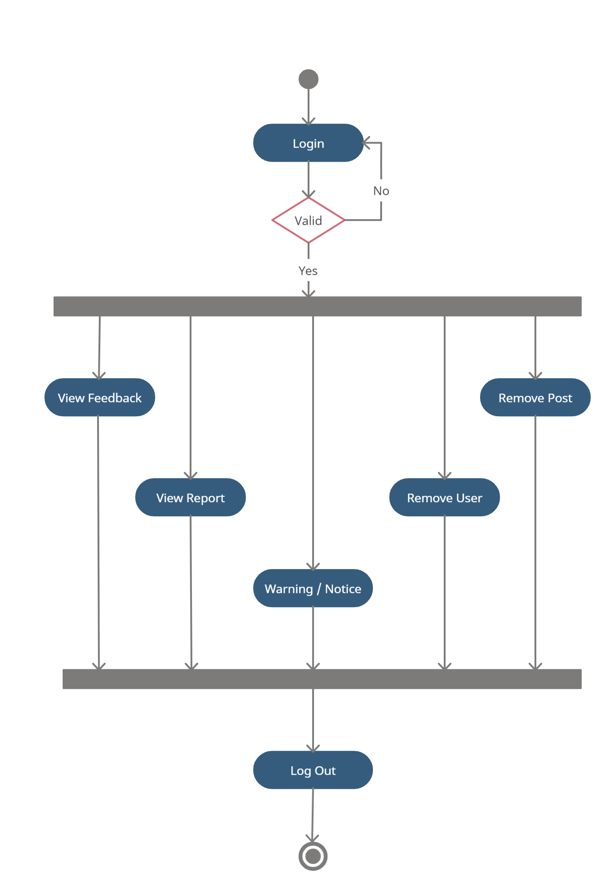

User Activity:

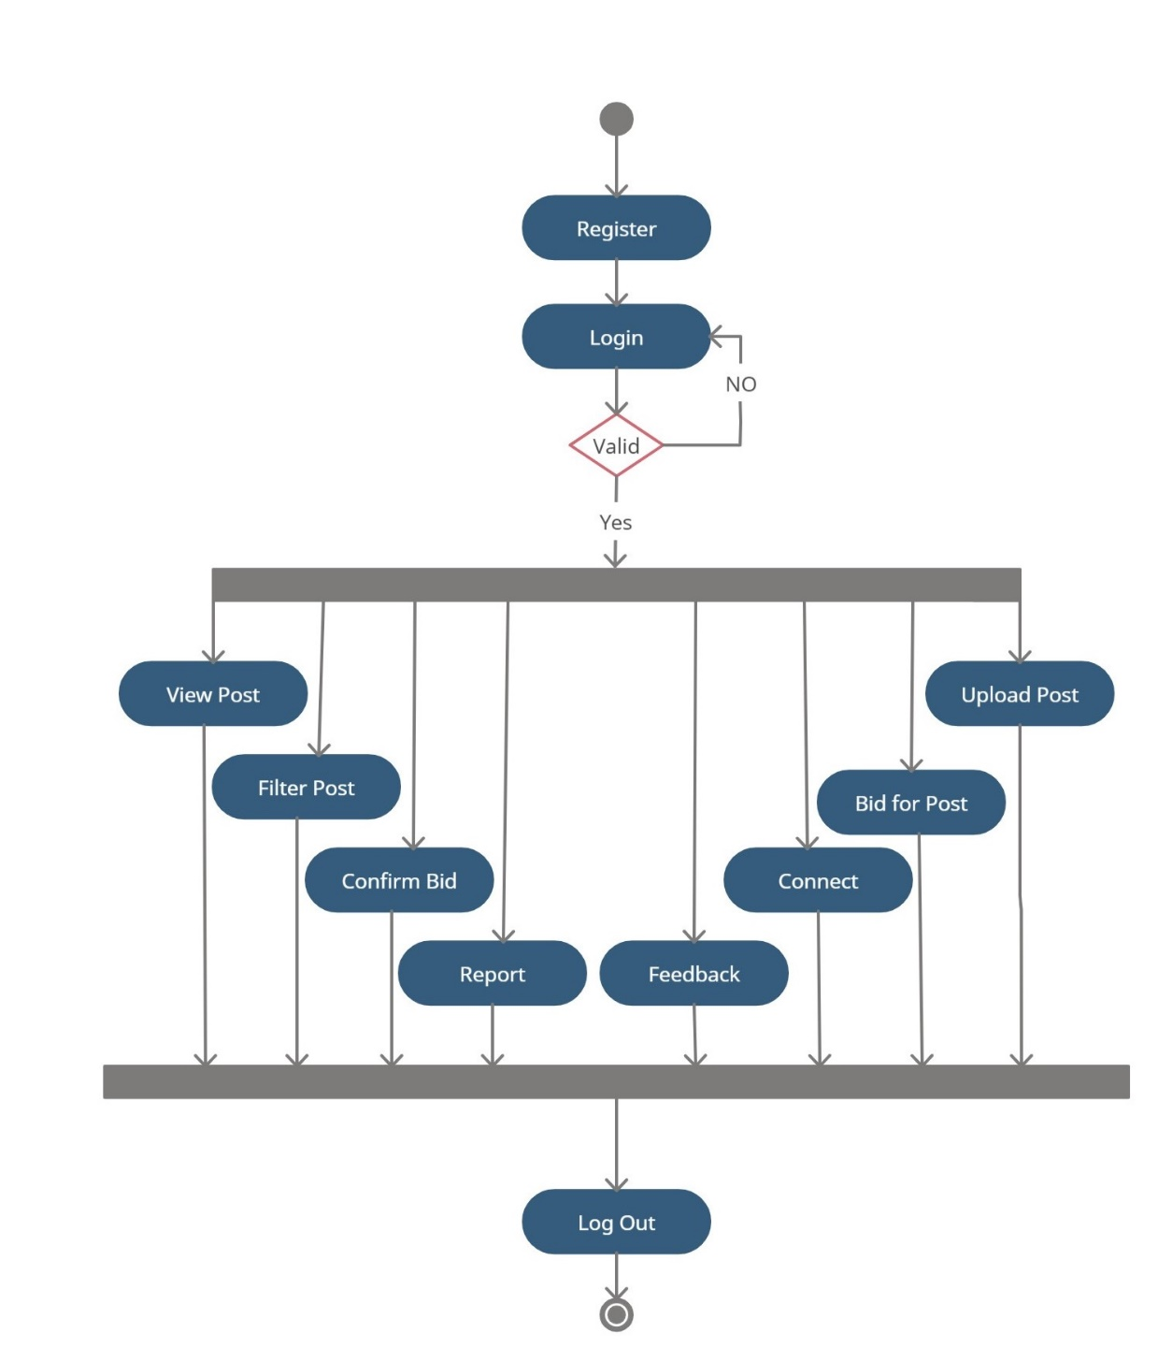

* **Use Case Diagram:**

Admin Use-case:

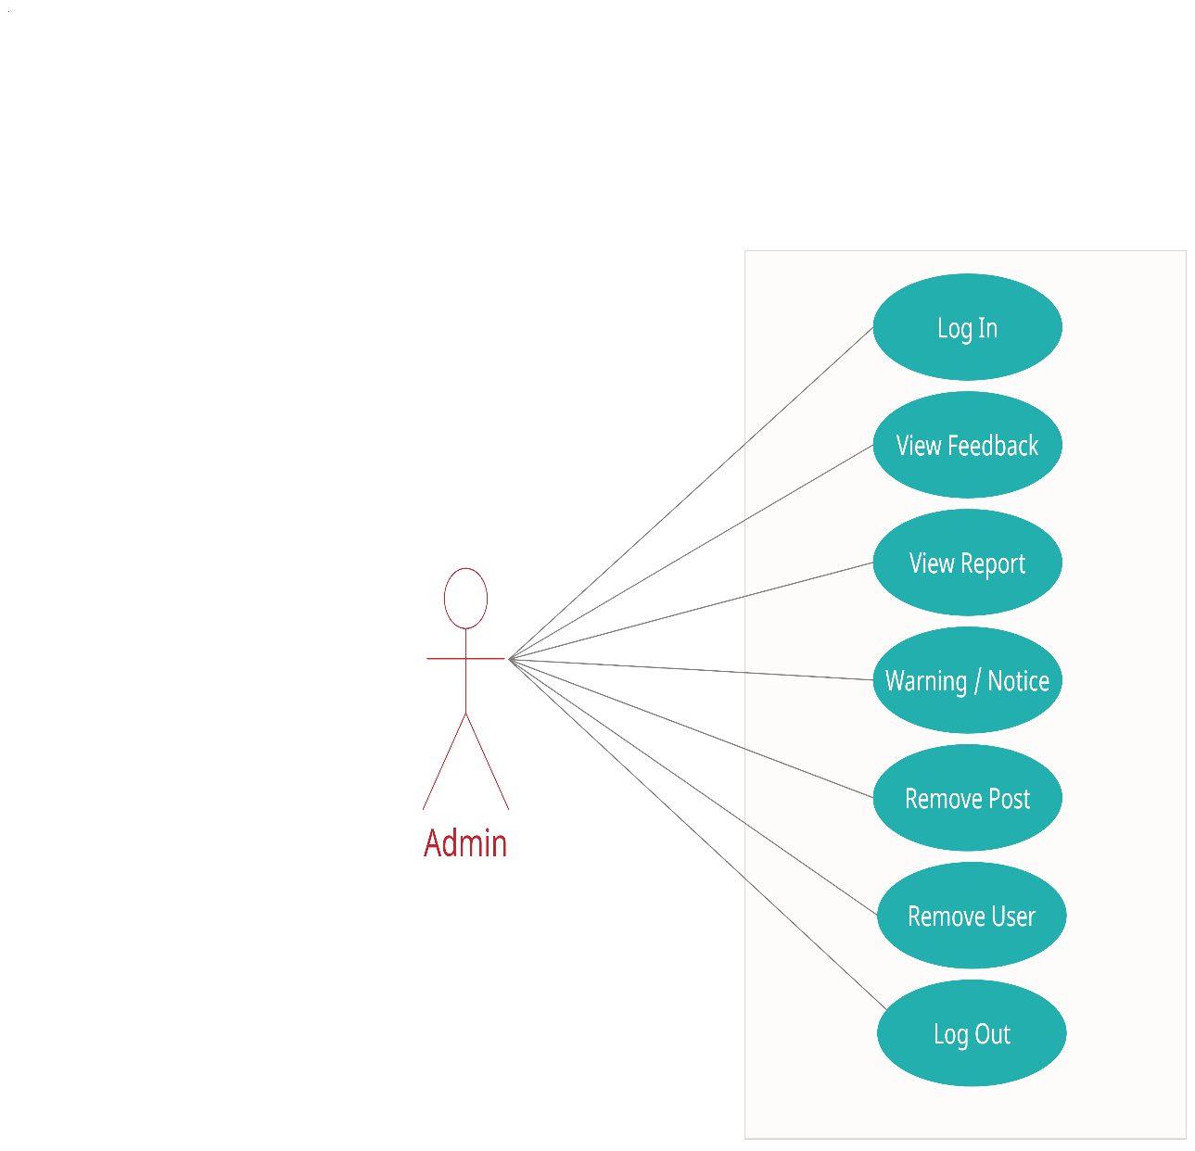

User Use-case:

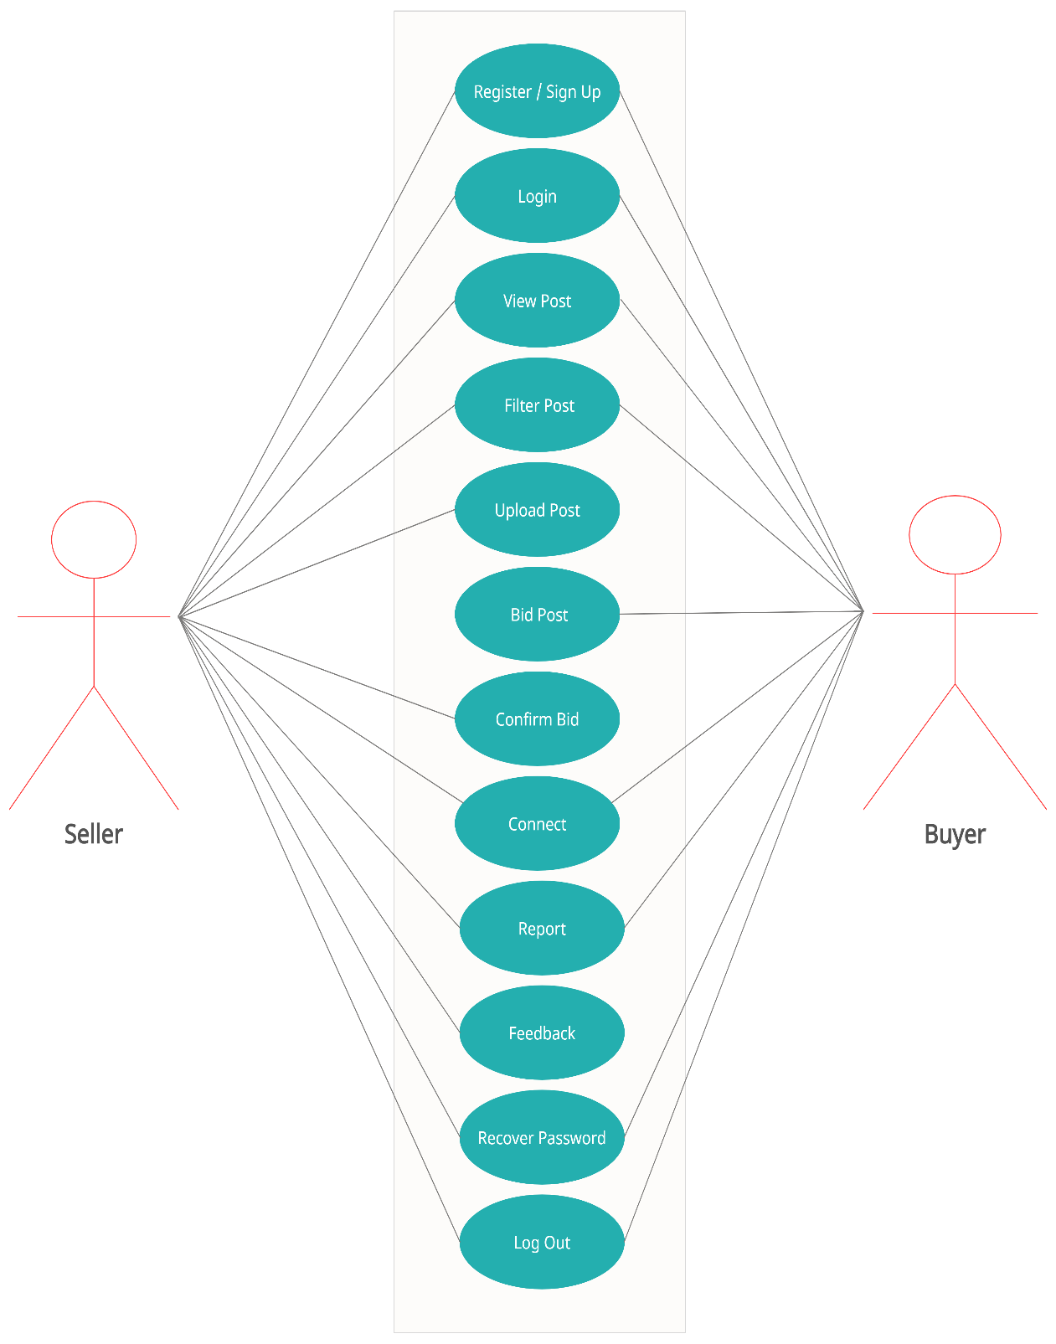

* **ER Diagram:**

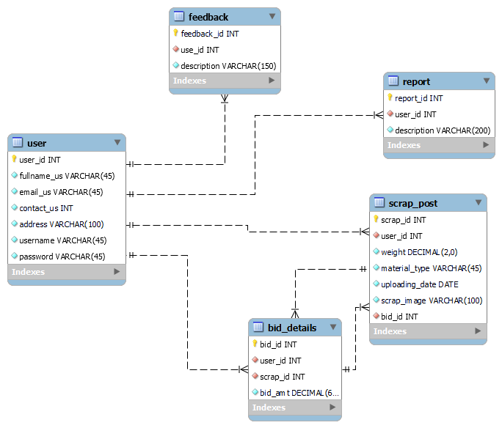

1. **Table Structure.**

* User

|  |  |  |  |  |
| --- | --- | --- | --- | --- |
| **Sr.** | **Field Name** | **Data type(Size)** | **Constraints** | **Description** |
| **No** |  |  |  |  |
|  |  |  |  |  |
| 1 | id (Primary) | int(11) | Primary Key | It is store User id |
|  |  |  |  |  |
| 2 | fullname | varchar(45) | Null | It is store User Full name |
|  |  |  |  |  |
| 3 | email | varchar(45) | Null | It is store email address of User |
|  |  |  |  |  |
| 4 | username | varchar(40) | Null | It is store Username |
|  |  |  |  |  |
| 5 | password | varchar(40) | Null | It is store Password |
|  |  |  |  |  |
| 6 | contactNo | varchar (10) | Null | It is store Contact no |
|  |  |  |  |  |
| 7 | address | varchar(45) | Null | It is store Address |
|  |  |  |  |  |

* Scrap Post

|  |  |  |  |  |
| --- | --- | --- | --- | --- |
| **Sr.** | **Field Name** | **Data type(Size)** | **Constraints** | **Description** |
| **No** |  |  |  |  |
|  |  |  |  |  |
| 1 | id (Primary) | int(11) | Primary Key | It is store scrap id |
|  |  |  |  |  |
| 2 | city | varchar(45) | Null | It is store city of User |
|  |  |  |  |  |
| 3 | weight | varchar(45) | Null | It is store Weight of Scrap |
|  |  |  |  |  |
| 4 | material_type | varchar(40) | Null | It is store Description |
|  |  |  |  |  |
| 5 | scrap_image | varchar(40) | Null | It is store Images of Scrap |
|  |  |  |  |  |
| 6 | uploadin_date | CurDate() | Null | It is store Date of Upload |
|  |  |  |  |  |

* Bid Details

|  |  |  |  |  |
| --- | --- | --- | --- | --- |
| **Sr.** | **Field Name** | **Data type(Size)** | **Constraints** | **Description** |
| **No** |  |  |  |  |
|  |  |  |  |  |
| 1 | id (Primary) | int(11) | Primary Key | It is store id |
|  |  |  |  |  |
| 2 | bidAmt | Decimal(10,2) | Null | It is store Bidding Amount |
|  |  |  |  |  |

* Feedback

|  |  |  |  |  |
| --- | --- | --- | --- | --- |
| **Sr.** | **Field Name** | **Data type(Size)** | **Constraints** | **Description** |
| **No** |  |  |  |  |
|  |  |  |  |  |
| 1 | id (Primary) | int(11) | Primary Key | It is store id |
|  |  |  |  |  |
| 2 | description | varchar(100) | Null | It is store Description of Scrap |
|  |  |  |  |  |
|  |  |  |  |  |

* Report

|  |  |  |  |  |
| --- | --- | --- | --- | --- |
| **Sr.** | **Field Name** | **Data type(Size)** | **Constraints** | **Description** |
| **No** |  |  |  |  |
|  |  |  |  |  |
| 1 | id (Primary) | int(11) | Primary Key | It is store id |
|  |  |  |  |  |
| 2 | description | varchar(100) | Null | It is store Description of Scrap |
|  |  |  |  |  |

1. **CONCLUSION**

* **Conclusion:**

This project aid in automating the existing manual system. This is a paperless work. It can be monitored and guarded remotely. It cut down the man power required and provides accurate information. All years together huddled information can be saved and can be accessed at any time. For this reason, the data stored in the repository helps in taking decision by management. So, it is improved to have a Web Based system. All the stakeholders, faculty and authority can get the required information without delay. This system is crucial in the colleges and universities.

* **Future Scope:**

In future this system can also be added with additional feature like Online Payment Gateway, Online Transportation Booking and 360⁰ view of scrap.

1. **REFERENCES.**

* **References:**

<http://www.ijcstjournal.org/volume-7/issue-1/IJCST-V7I1P4.pdf>



<https://bootstrapmade.com/mentor-free-education-bootstrap-theme/>



<https://www.javatpoint.com/java-mail-api-tutorial>



[https://javaee.github.io/javaee-spec/javadocs/](https://javaee.github.io/javaee-spec/javadocs)



<https://www.w3schools.com/>

